**KEELO SOFT**

**by JPT**

Disclaimer

We have taken great care in accurately compiling information. J P Techatronics makes no warranty, express or implies including without limitation any warranty concerning the accuracy, or completeness of such information or material. J P Techatronics is not responsible for any problems that arise or any associated costs or manner based on the information provided here in.  
The company also reserves right to remove content any time without obligation to notify any person or entity of any alterations.

**Introduction**

Keelo Soft by J P Techatronics for controller and automation of different custom equipment machine like batch plant, mixers, etc. Where in a data acquisition system is present already with user interface guided by process flow.

**Application**

Used for different custom equipment machine like batch plant, mixers, etc illustration below

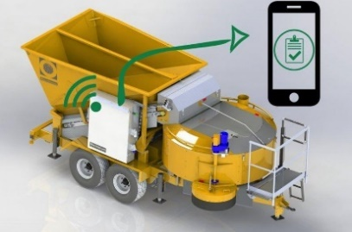 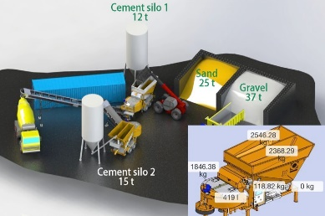 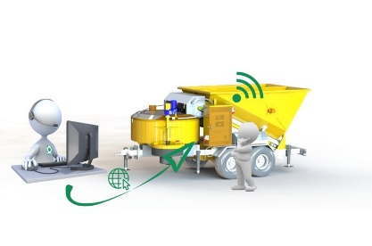

**Systems Safety Precaution**

* Only qualified and trained Employees may work on or near Exposed Energized Electrical Parts or Electrical Equipment.
* Stand on Insulated safety mat /Install safety mat on Floor where you stand
* Safety glasses must be used in jobs like cutting, drilling & while using air blower.
* Hand protection in the form of suitable gloves should be used for handling hot objects, glass, or sharp-edged items.
* When using an interlock as a safety device, ensure that it of a fail-safe design.
* De-energize electrical circuits before repairs are made. Use a LOCK on main switch. Take out a electrical panel key after locking the electrical panel and during Mixer maintenance.
* Isolate equipment controlled by the automation systems from the control system.
* Safety Shoes must be worn in shop area compulsorily.
* Do not stand directly in front of an electric panel when operating the disconnecting means or operator switch.
* Before connecting the power supply ensure that no individual is working on the panel/machine.
* While working / testing on connected Motors, Keep the motors locally earthed.
* Ensure or remove loose clothing or jewelry (watches, rings etc) before working  
  on a machine or panel.
* Watch out for sparks, burning smell, smoke or short circuits in the workshop
* To avoid damage of multi-meter, do not use Multi-meter in Current mode/ series current mode to check Voltages.
* Ensure emergency contacts are available to you, e.g. First Aid, Vehicle, Driver, Phone contacts, person to aid you.

DO’S AND DONT’S - Safety

Safety Test:

* Check direction of mixer motors one by one. For inclined belt remove V-belts and  
  take trial for direction of the motor. Then connect the belts to gearbox.
* Keep the Mixer Area Emergency S/w in depressed position and put ON the mixer  
  MCCB / MCB.
* Ensure mixer to be empty and the gate to be closed.
* Operate Mixer through manual PB and confirm that mixer does get ON.
* Now release the Emergency S/w, Open the mixer Hatch and repeat the above  
  step.
* Close mixer hatch, and start mixer and stop, confirm the mixer shaft rotation to be  
  proper through inspection window.
* After confirming the direction run the mixer for some time and observe.
* Confirm mixer no load current to be as per manufacturers specifications.
* Press Emergency S/w and confirm that the mixer stops.
* Run the mixer again and with due care open mixer hatch to ensure that the mixer  
  stops.
* Carryout similar activities for Skip/Belt, Silo area etc. and ensure proper safety  
  operation and direction of rotation of each equipment.
* In Case of Skip it is advisable to simulate sensor / limit s/w operation and confirm  
  proper skip operation & signal.

Interlocks:

* Ensure following operational interlocks, as configured in the software.
* Skip/Belt operation with respect to Mixer and Mixer gate status.
* All weigher gate operations with respect to Mixer and Mixer gate status.
* Aggregate discharge operation with respect to Belt status / Skip position.
* Feeding of each material with respect to weigher gate position

**Configuration Sensors Parameters**

* Transfer Type: In this section Aggregate Transfer type can be selected for Aggregate scale.  
  • Weighing Skip  
  • Transfer Skip  
  • Transfer Belt  
  • Transfer Belt with Waiting Hopper  
  • Direct

Transfer Belt:

* Belt Operation: Select Belt Operation Auto/Manual. If manual is selected, then the  
  user needs to manually Switch On & Off the belt.
* Belt Control: Select Belt operation between “Intermittent” or “Continuous”. If  
  ‘Intermittent’ is selected, then the transfer belt starts & stops after discharging each  
  aggregate batch. If selection is ‘Continuous’, then the belt stops after completion of  
  last batch of a full load.
* Belt Sequence: Select Belt to be started in Time based or Sequence based. If  
  selected, time based, then the belt starts immediately once the load is started.
* Belt Transfer Time: Enter the time taken by an aggregate materials to reach waiting  
  hopper / mixer after discharging from the aggregate / weighing conveyor.
* Belt Pre-Run Time: It is the time for which the belt will run for 75% of belt transfer  
  time defined so that the partial aggregate materials from the aggregate conveyor  
  discharges. This shall increase the plant productivity by reducing the total cycle time. (Note: Please check the mechanical arrangements before enabling this feature.)
* Belt Delta Delay: Here, define the delay time to switch on the Transfer Belt motor  
  from Star to Delta.
* Belt On Delay: This is the time delay to start the transfer belt motor after oncommand is received.
* Belt Off Delay: This is the time delay to stop the transfer belt motor afterdischarging the aggregate materials.
* Belt Hooter Time: The system shall buzzer for the defined time before starting thebelt

Waiting / Preload Hopper:

* Waiting Hopper Sensor: User can select the presence of Level Sensors by “Yes /  
  No”.
* Hopper Discharge Time: Enter the time taken by the waiting hopper to discharge all  
  aggregate materials into the mixer.
* Hopper Discharge Half Time: Enter the time to discharge aggregate materials from  
  waiting hopper in to mixer.
* Hopper Full Open Time: Enter the time taken by the hopper gate to reach its fully  
  opened position.
* Hopper Close Time: Enter the time taken by the hopper gate to reach its fully open  
  to closed position.
* Hopper Half Open Time: Enter the time taken by the hopper gate to reach its mid  
  position.

**Alarms Sensors**

* Aggregate Filling Fault Alarm
* Cement Dead Weight Fault Alarm
* Additives Dead Weight Fault Alarm
* Water Filling Fault Alarm
* Additives Filling Fault Alarm
* Aggregate Discharge Fault Alarm
* Cement Discharge Fault Alarm
* Water Discharge Fault Alarm
* Additives Discharge Fault Alarm
* Skip Waiting Position Fault Alarm
* Skip Up Position Fault Alarm
* Skip Down Position Fault Alarm
* Mixer Gate Open Fault Alarm
* Mixer Gate Close Fault Alarm
* Aggregate Hopper Gate Close Alarm
* Cement Hopper Gate Close Fault Alarm
* Additives Discharge Valve Alarm
* Mixer Not Running Alarm
* System in Manual Mode Alarm
* PLC is On Hold Condition Alarm
* Aggregate out of Tolerance Alarm
* Cement out of Tolerance Alarm
* Water out of Tolerance Alarm
* Additives out of Tolerance Alarm

**Flow Chart**

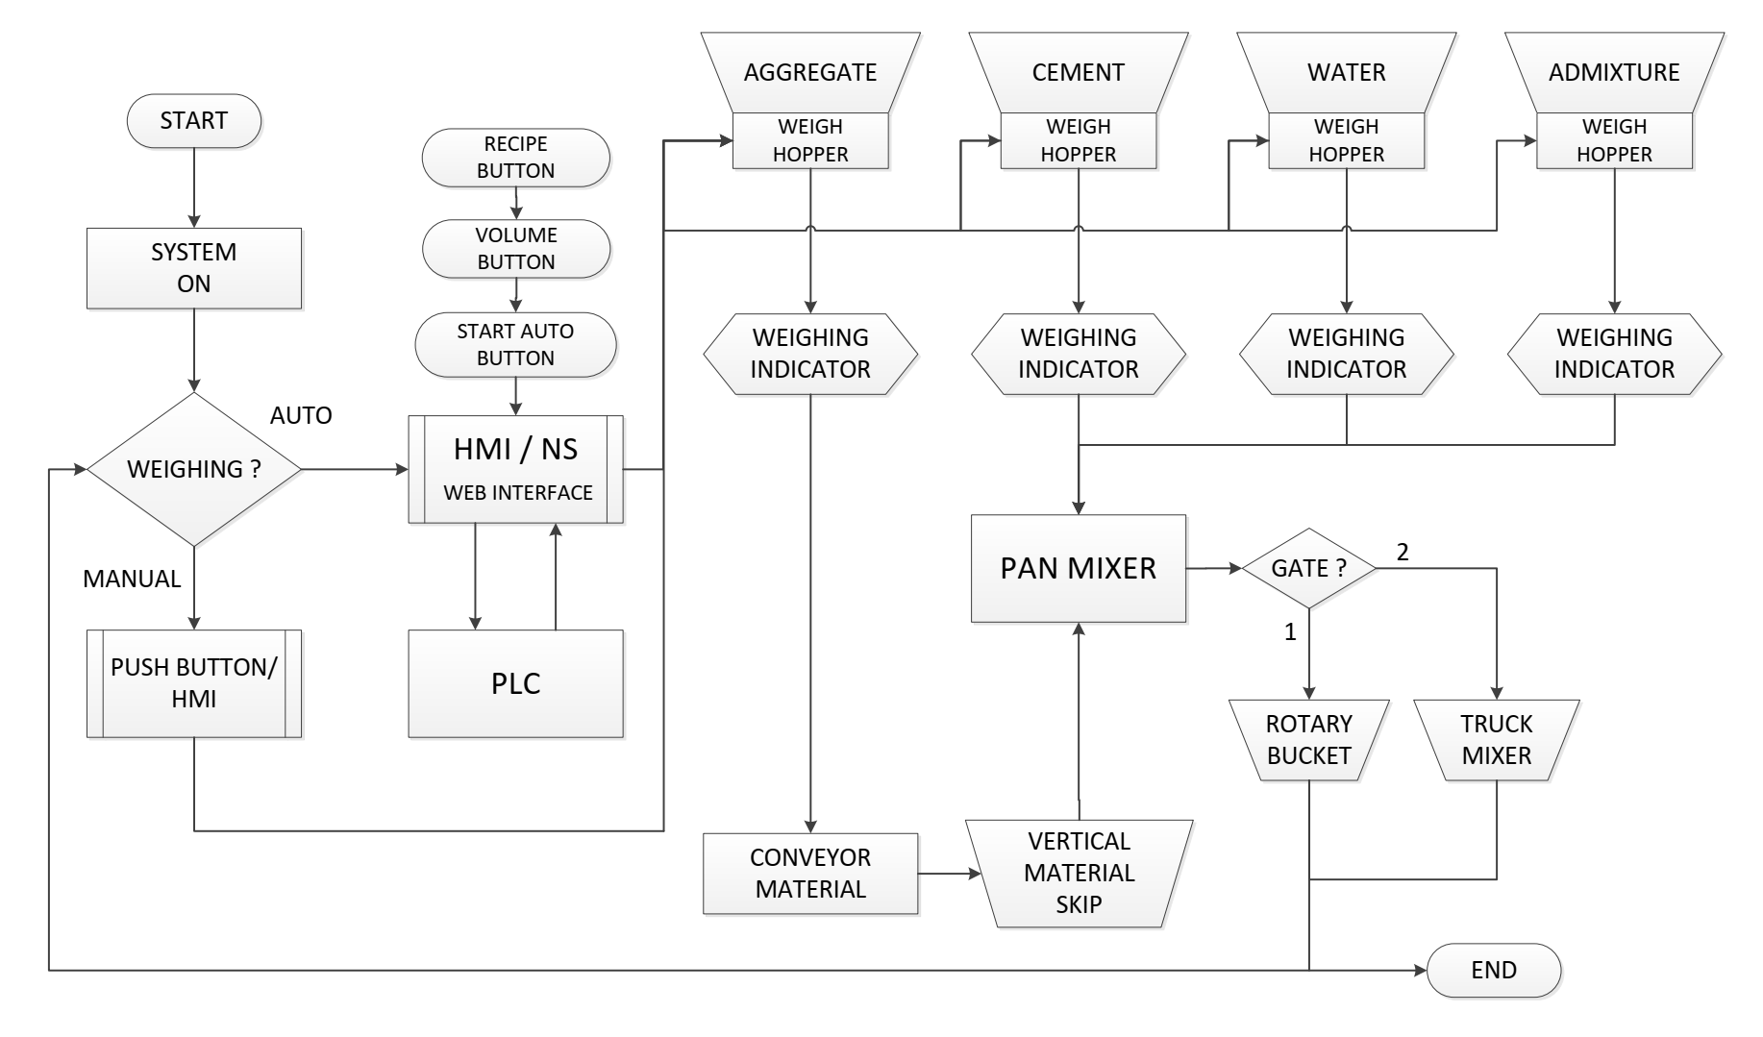

Manual Run :  
Input Signals :

* Put ON the mixer and confirm proper star to delta transition.
* Ensure the mixer ON feedback input is indicated in the PLC.  
  • Similarly operate other moving equipment and check for following feedback indications on PLC.
* Transfer belt ON feedback ( True when ON).
* Skip Ascending and Skip Descending feedback (True when ON).
* Aggregate Extractor belt (False when ON) or Aggregate hopper gate close feedback (True when Closed).
* Cement Weigher gate close feedback ( True when Closed).
* Water Weigher gate close feedback (True when Closed).
* Additive Weigher gate close feedback ( True when Closed or False when Discharge  
  Motor ON)

Output Signals :

* Additive Weigher gate close feedback ( True when Closed or False when Discharge  
  Motor ON)
* In Case of Skip it is advisable to simulate sensor / limit s/w operation and confirm proper skip operation & signal.
* Put ON each Aggregate bin and physically check for respective bin gate operation.
* Repeat above step for each ingredient of Cement, Water Additive etc.